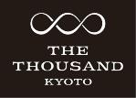
NEWS RELEASE
To: All news media outlets
May 21,2019
Keihan Hotels & Resorts Co., Ltd.
THE THOUSAND KYOTO

The Flagship Hotel of Keihan Group
【 THE THOUSAND KYOTO 】

Making its presence felt: A global hotel full of appeal offering premium Kyoto stays
is now a member of Preferred Hotels & Resorts
THE THOUSAND KYOTO joins more than 750 hotels in over 85 countries, the hospitality group is the world’s largest independent hotel brand

Keihan Hotels & Resorts Co., Ltd. (Head office: Shimogyo Ward, Kyoto City. President: Toshihiko Inachi) has announced that as of April 25, 2019, ‘THE THOUSAND KYOTO (ザ・サウザンド キョウト)’, the flagship hotel of the Keihan Group, will enter into membership of Preferred Hotels & Resorts, the world's largest independent hotel brand. Affiliated with the Lifestyle Collection, which encompasses premium hotels that offer unbeatably appealing hotel stays, the hotel will strive to improve global awareness and impact, expand its base and attract wide-ranging worldwide guests from leisure travel to the MICE (meetings, incentives, conferences, exhibitions) market.
'THE THOUSAND KYOTO’, which embodies the concept of a ‘Personal Comfort Hotel,’ tapping into the abundant wisdom of Kyoto, goes beyond luxury to offer guests the finest sensory experience and unrivaled enjoyment that draws on its insights, both locally and nationwide. Building on its ability to deliver new and unique Kyoto experiences, THE THOUSAND KYOTO aims to leverage this membership and go from strength to strength as a global hotel, with unmatched capacity to convey the real charm of Kyoto and all of Japan.
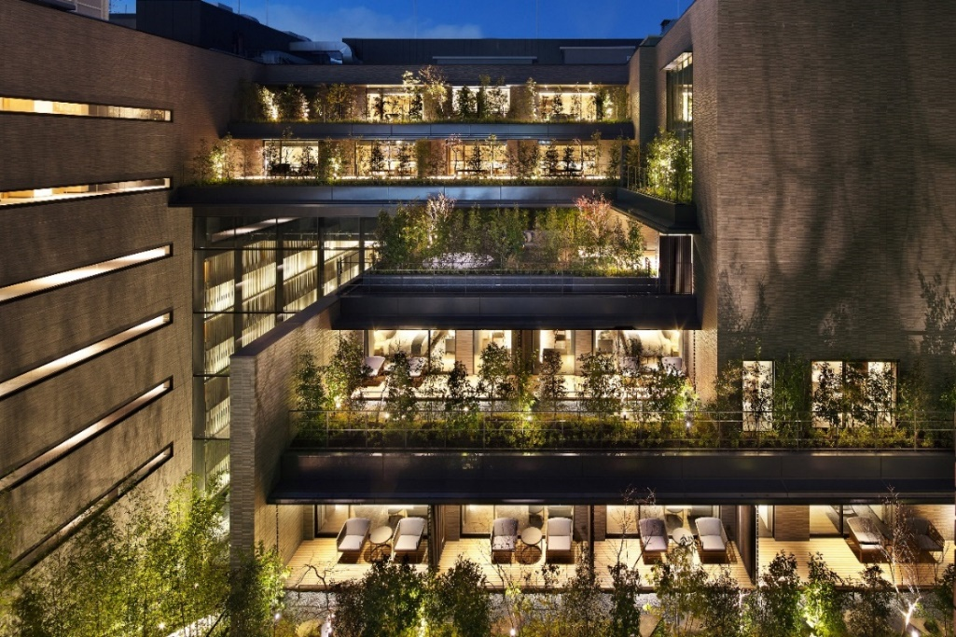

> Cloaked in abundant greenery and with a pleasing sense of order, the architecture and landscape of the hotel echo its stylized beauty: the epitome of a ‘downtown rural escape’.

> Preferred Hotels & Resorts
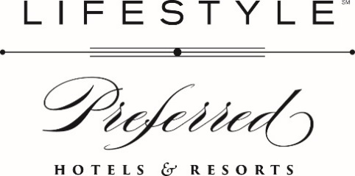

【Head office location】(California, USA) 26 Corporate Plaza, Suite 150 Newport Beach, CA 92660 USA
【Representative】 Ms. Lindsey Ueberroth, Chief Executive Officer
【Year of founding】1968
【Member hotels】 More than 750 hotels (over 160,000 rooms) in 85 countries worldwide.
* Information current as of May 2019
【Japan office】 Royal Park Hotel 2F, 2-1-1 Nihombashi Kashiwacho, Chuo Ward, Tokyo
【Managing Director, Japan】 Kaori Yamaguchi (山口芳)
【Official site】https://preferredhotels.com/

【Collection: Lifestyle】
*Definition: Intimate and luxurious hotels, the Lifestyle Collection offers a brilliant life and style. A diverse collection of premier global properties offering engaging stays and memorable moments. Authentic, intelligent, and approachable, this collection presents responsive service and local dining that articulate culture and style.

＞THE THOUSAND KYOTO aims to win a place in guests’ hearts worldwide as a single special place offering the best of Kyoto culture, beauty, art, dining, experiences and the very essence of hospitality.

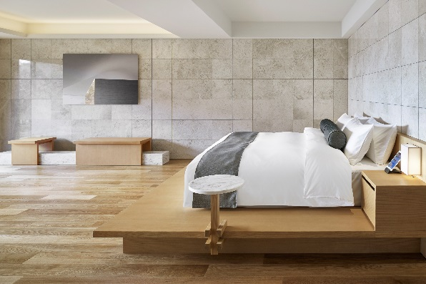
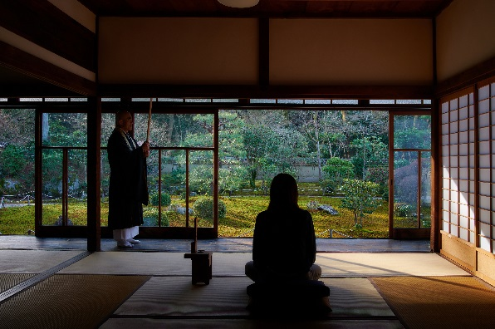

<OKUTRIP>
Know and take on board unique ‘Deep Kyoto’ experiences with our special programs, exclusively for staying guests. Let our concierge showcase places no guidebook will show you, people you’ll never otherwise meet and stories you’d never normally hear - welcome to ‘Deep Kyoto’ - an experience even most locals will never enjoy.
<Guestrooms>
In the best of Zen traditions, adopting a design that eliminates the superfluous and brings out the very best in greenery, light and art. Enjoy soft and special lighting amid a uniquely Japanese-style low configuration, delivering a space full of peace and freshness and reminiscent of a Kyoto-style machiya townhouse.

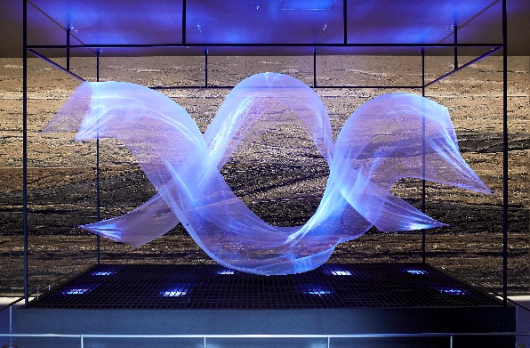
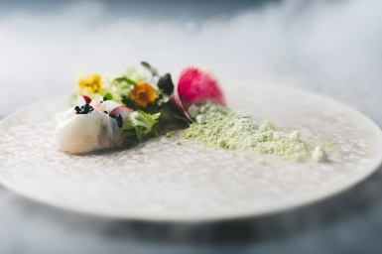

<Dining experience>
Stillness and movement, where tradition and creative sparks come together, with our famous ‘dashi fish stock’ the culinary highlight of our Japanese cuisine. “Representing edible worldwide wonders”, our innovative in-house ‘Italian’ dining encompasses elements of Kyoto, Japan, Italy and even beyond at times. Our ‘cafe and bar’ - a venue embodying the contemporary tea ceremony experience. Within three in-house venues, let our hotel take you on unique culinary journeys.
<Art>
Amid a theme evoking millennial eternity, 'UTSUROI / YURAGI’ which epitomize all things in perpetual motion. Exemplifying how we interact with Kyoto nature; drawing on elements of nature, greenery and light and blown by the wind, this is a place to encounter art across the board that celebrates the charm of the changing seasons.

<Facility Configuration>
B1F: Parking lot, fitness area, mini ballroom, beauty salon
1F: Entrance (parking lot, street garden), lobby (grand stairs), reception, ballroom, medium banquet room, waiting room
2F: Wedding salon, dressing room, restaurant (Japanese / Italian), cafe & bar
Spa (treatment room), florist
3F: Chapel, garden, guestrooms, spa (reception, hot bath, stone spa, sauna)
4F～9F: Guestrooms
* Linked to the adjacent Kyoto Century Hotel on floors 1 to 3

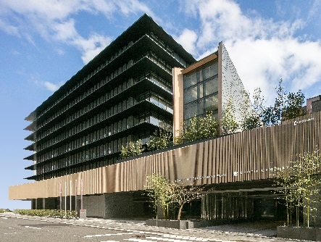
THE THOUSAND KYOTO (ザ・サウザンド キョウト)
Location: 570 Higashishiokoji-cho, Shimogyo Ward, Kyoto City 600-8216
Access: Around 2 minutes’ walk east of JR Kyoto Station
Opening date: January 29, 2019 (Tue.)
No. of floors: B1～9F (guestrooms: 3F～9F/ 222 rooms)
HP: https://www.keihanhotels-resorts.co.jp/the-thousand-kyoto

<Enquiries about this release / coverage>
Keihan Hotels & Resorts Co., Ltd.
The Thousand Kyoto Heads of PR: KAYA / MORI
Tel.: +85-75-351-0186 Fax: +81-75-343-3722
Email: kaya-k@keihanhotels-resorts.co.jp

